Software Design Specifications

Project Name

Version: [1.0]

Project Code
Supervisor
Co Supervisor
Project Team
Submission Date

Document History
[Revision history will be maintained to keep a track of changes done by anyone in the document.]
Version | Name of Person | Date | Description of change

Distribution List

Name | Role

Document Sign-Off

Version | Sign-off Authority | Project Role | Signature | Sign-off Date

Document Information

Category | Information

Definition of Terms, Acronyms and Abbreviations

Term | Description

Table of Contents
1 Introduction 7
1.1 Purpose of Document 7
1.2 Intended Audience 7
1.3 Document Convention 7
1.4 Project Overview 7
1.5 Scope 8
2 Design Considerations 9
2.1 Assumptions and Dependencies 9
2.2 Risks and Volatile Areas: 10
3 System Architecture 12
3.1 System Level Architecture 12
3.2 Software Architecture 14
4 Design Strategy 15
5 Detailed System Design 17
5.1 Database Design 18
5.1.1 ER Diagram 18
5.2 Application Design 19
5.2.1 Sequence Diagram 19
5.2.1.1 Sign Up 19
5.2.1.2 Log In 20
5.2.1.3 Set Electronic Appliance 21
5.2.1.4 Recognize Gesture 22
5.2.1.5 Perform Action on the electronic appliance 23
5.2.2 Dataflow Diagram 24
6 References 25
7 Appendices 26

Introduction
The Real-time Shopping Mall Safety and Security System (RSSS) aims to enhance safety and security in shopping malls by providing a comprehensive solution for fire detection, theft prevention, and emergency management. This System Design Specification (SDS) document outlines the overall architecture and design of the RSSS, providing a detailed overview of its components, their interactions, and the design principles that govern its operation.

Purpose of Document
The purpose of this SDS is to:
- Define the overall system architecture of the RSSS, including hardware and software components and their interactions.
- Guide the system implementation by providing detailed specifications for each component.
- Facilitate system maintenance and upgrades by serving as a reference for future modifications.

Intended Audience
This SDS is intended for:
- System architects and developers responsible for designing and implementing the RSSS.
- Project stakeholders who need to understand the system's architecture and design principles.
- System maintenance personnel who will be responsible for future upgrades and modifications.

Document Convention
This SDS adheres to the following conventions:
- Components are referred to using consistent naming conventions.
- Diagrams are labeled and annotated for clarity.
- Technical terms are defined and explained.

Project Overview
The RSSS aims to address the following safety and security concerns in shopping malls:
- Fire detection and alarm system to detect and alert authorities in case of a fire.
- Theft detection and alert system to identify and notify security personnel about potential theft attempts.
- Voice assistant for guidance and assistance to shoppers, providing directions and emergency information.
- Emergency evacuation management to guide occupants to safety in case of an emergency.

Scope
The RSSS aims to address the following safety and security concerns in shopping malls:
- Fire detection and alarm system to detect and alert authorities in case of a fire.
- Theft detection and alert system to identify and notify security personnel about potential theft attempts.
- Voice assistant for guidance and assistance to shoppers, providing directions and emergency information.
- Emergency evacuation management to guide occupants to safety in case of an emergency.

Design Considerations

Assumptions and Dependencies
The design of the Real-time Shopping Mall Safety and Security System (RSSS) is based on the following assumptions and dependencies:
- The shopping mall will have a reliable power supply and internet connectivity to ensure uninterrupted operation of the system.
- Sensors and cameras deployed throughout the mall will provide accurate and timely data for fire and theft detection.
- The voice assistant module will have access to a comprehensive database of mall information and emergency protocols.
- Mall occupants will have access to smartphones or other devices to receive emergency notifications and interact with the voice assistant.

Risks and Volatile Areas:
The following risks and volatile areas have been identified in the design of the RSSS:
- False alarms: The system may generate false alarms due to sensor malfunctions or environmental factors, leading to unnecessary disruptions and potential panic among mall occupants.
- Cybersecurity threats: The system's reliance on internet connectivity and data transmission makes it vulnerable to cyberattacks, potentially compromising sensitive information or disrupting emergency response efforts.
- Integration challenges: Integrating multiple hardware and software components into a cohesive system may pose challenges in terms of compatibility, data synchronization, and overall system performance.
- Human error: The effectiveness of the system depends on the proper actions of mall staff and security personnel in response to alerts and emergency situations. Training and clear protocols are essential to minimize human error.
Mitigation strategies to address these risks include:
- Implementing redundant sensors and data validation algorithms to reduce false alarms.
- Employing robust cybersecurity measures, such as encryption and access control mechanisms, to protect against cyberattacks.
- Thorough testing and validation of system integration to ensure seamless communication and data exchange between components.
- Comprehensive training and regular drills for mall staff and security personnel to ensure proper response procedures in case of emergencies.

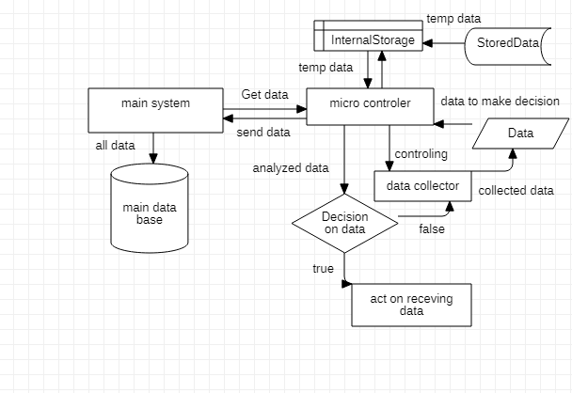
System Architecture

In above figure, we have our own database, which is a temporary. Database collects the data of our micro controller. Live camera video will be saved in the database for two days, after which the film will be automatically deleted. Data is collected from the sensors and sent to the micro-controller through the data collector. If any unusual activity discovered, the micro-controller will communicate it and GSM act on receiving data.

System Level Architecture
The system level architecture comprises three main layers:
- Sensor Layer: This layer consists of various sensors responsible for detecting fire, smoke, temperature, motion, and human presence. These sensors collect real-time data from the environment and relay it to the processing layer.
- Processing Layer: This layer acts as the central hub of the system, receiving data from the sensor layer and utilizing image processing techniques to analyze the data. The processing layer runs on a portable device with adequate processing power and graphics capabilities.
- Actuation Layer: This layer is responsible for initiating appropriate responses based on the analysis from the processing layer. It triggers alarms, sends alerts to rescue teams and the mall owner, activates lights, and provides voice assistance for evacuation.

Software Architecture
The software architecture of the RSSS is divided into three main modules:
- Fire Detection Module: This module utilizes data from smoke, flame, and temperature sensors, along with image processing, to detect fire. Upon detection, it triggers alarms, sends alerts to rescue teams, and provides voice assistance for evacuation.
- Theft Detection Module: This module employs motion detection sensors and image processing to identify intruders. When an intruder is detected, it activates lights, alarms, and sends real-time alerts to the mall owner.
- Voice Assistance Module: This module provides public service guidance and helps locate fire exits in emergencies. It interacts with users through voice input and provides appropriate instructions.

Design Strategy
Ensuring the safety and security of shoppers and staff in a shopping mall environment requires a comprehensive and well-integrated system that can monitor, detect, and respond to potential threats in real time. The design strategy for such a system should address the following key considerations:

Use of a particular type of product:

Reuse of existing software components to implement various parts/features of the system:

Future system extension or enhancement:

User interface paradigms (or system input and output models):

Error detection and recovery:

Data management:

Concurrency and synchronization:

Detailed System Design

Database Design

ER Diagram

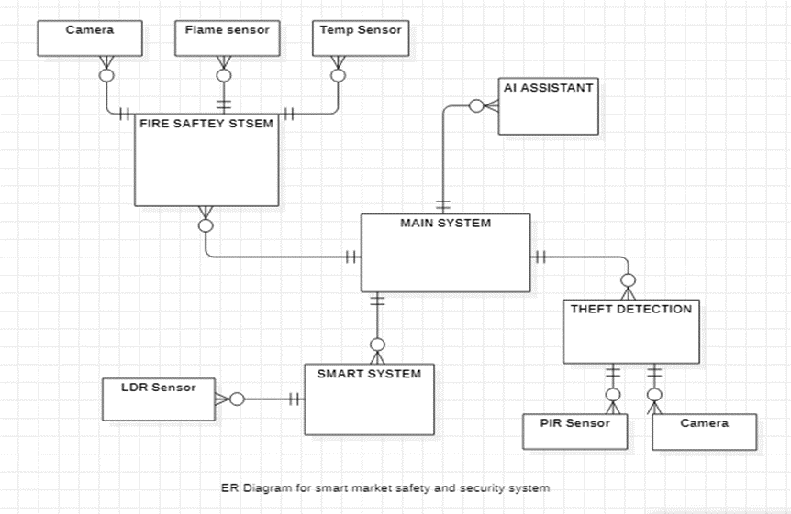

Application Design

Sequence Diagram
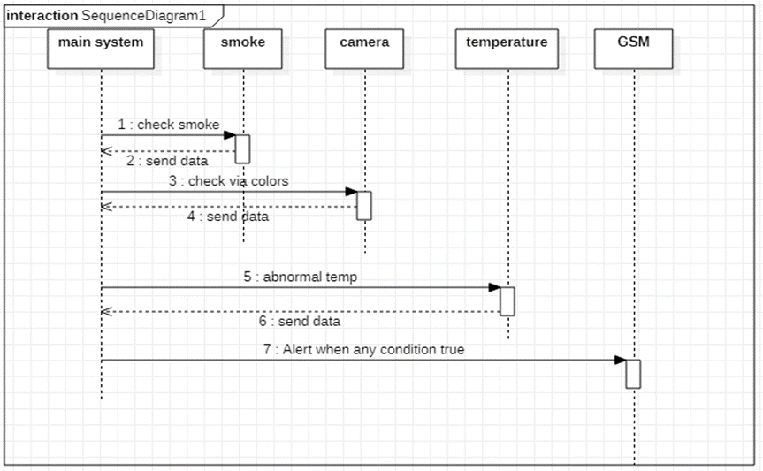
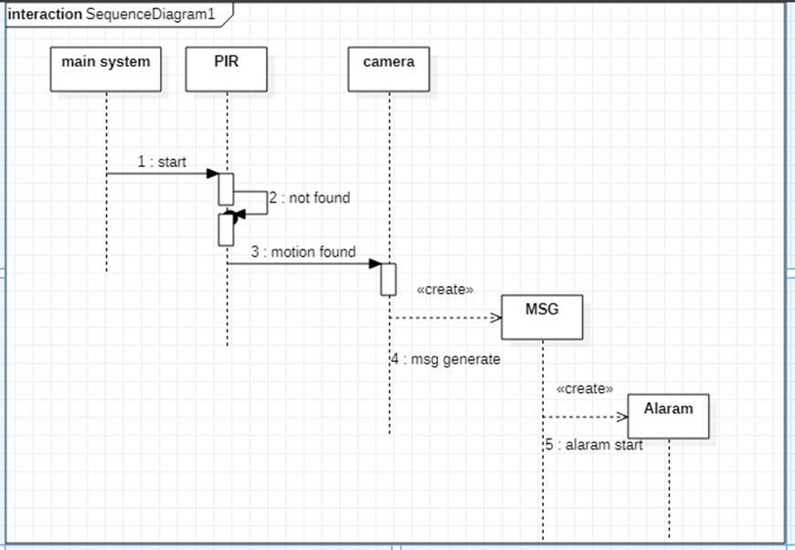

Dataflow Diagram

References
N/A

Appendices
N/A

